**Installation Guidelines**

**System Requirements**

* Windows OS 8/10 64-bit
* MAC OS X 10.10 or higher
* X86_64 CPU Architecture
* 2nd Generation Intel Core, AMD
* At least 4 GB RAM
* At least 4 GB of disk space
* 1280x800 screen resolution
* At least 1.7 JDK version

**Hard Requirement**

* External Android Device
* Type C or Micro USB cable

**Guidelines for Installation Setup**

The user can download the Android Studio, JDK by the clicking in the below link:

[Download the latest version of Android Studio from here](https://developer.android.com/studio?gclid=Cj0KCQjw1tGUBhDXARIsAIJx01n2U3SdmJtocPHIFvZfU8fgLsQxaIHmJwrSHYJPY2YOwDbTmowObU8aAiE7EALw_wcB&gclsrc=aw.ds)

[Download the latest version of JDK from here](https://www.oracle.com/java/technologies/downloads/)

The user need to download the latest version of Android Studio and JDK version as suggested by developers.

**Steps**

1. If the file is in *.exe* format double click and run it.
2. For the file .zip, unpack the ZIP and copy the Android Studio folder into preferred directory and then open *studio.exe*.
3. Install the Android Studio into your system and provide the specific location as shown in Fig1.

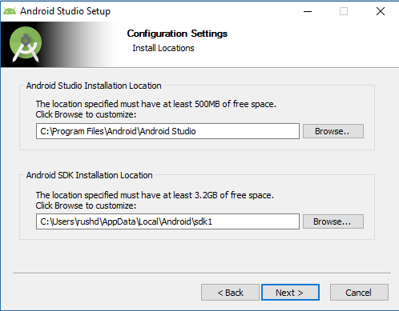

Fig 1: Android Studio Setup

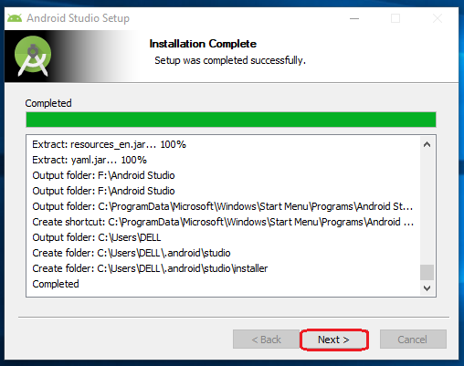

Fig 2: Android Setup Installation Success

1. After successfully installing the Android Studio run the program.
2. Then the user must enable the developer option in their android device. Go to Settings > About Phone > Tap Build Number or MIUI version 10 times

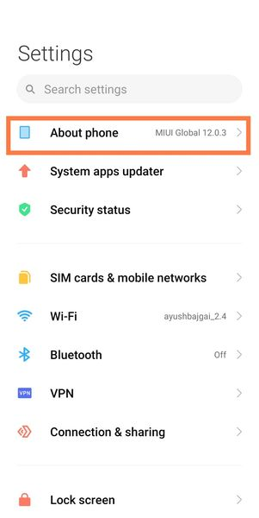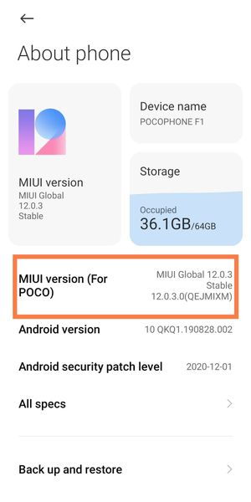

Fig 3: Enabling Developer Option

1. After enabling the developer option, the user then now need to enable the USB debugging. Go to Additional Settings > Developer Options > Search for USB Debugging > Enable USB debugging and Install via USB

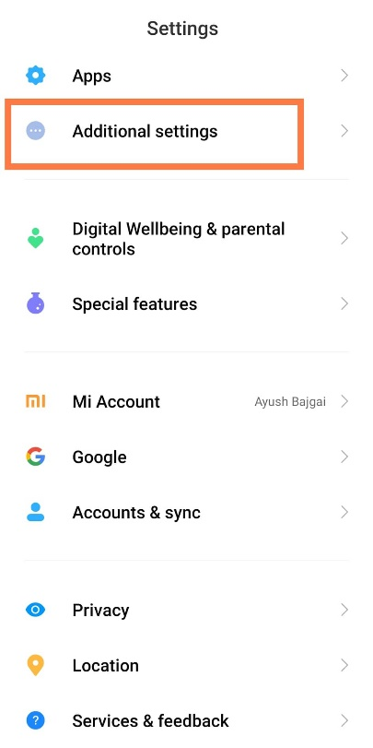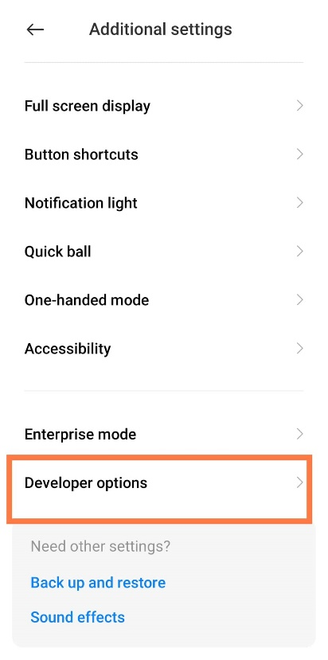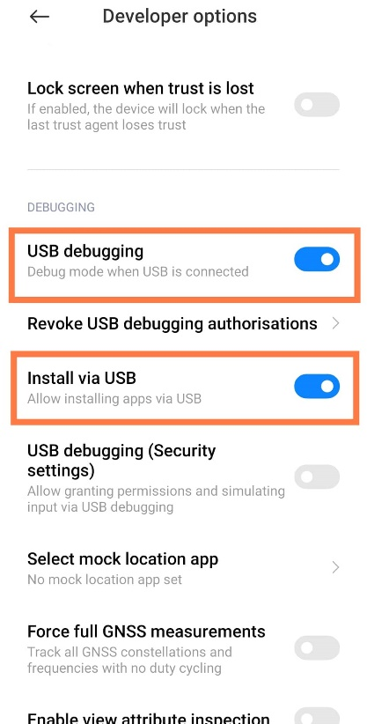

Fig 3: Enabling USB Debugging

1. Open Android Studio
2. Go to File > Open > Search for the FinalYearProject for where the user has downloaded

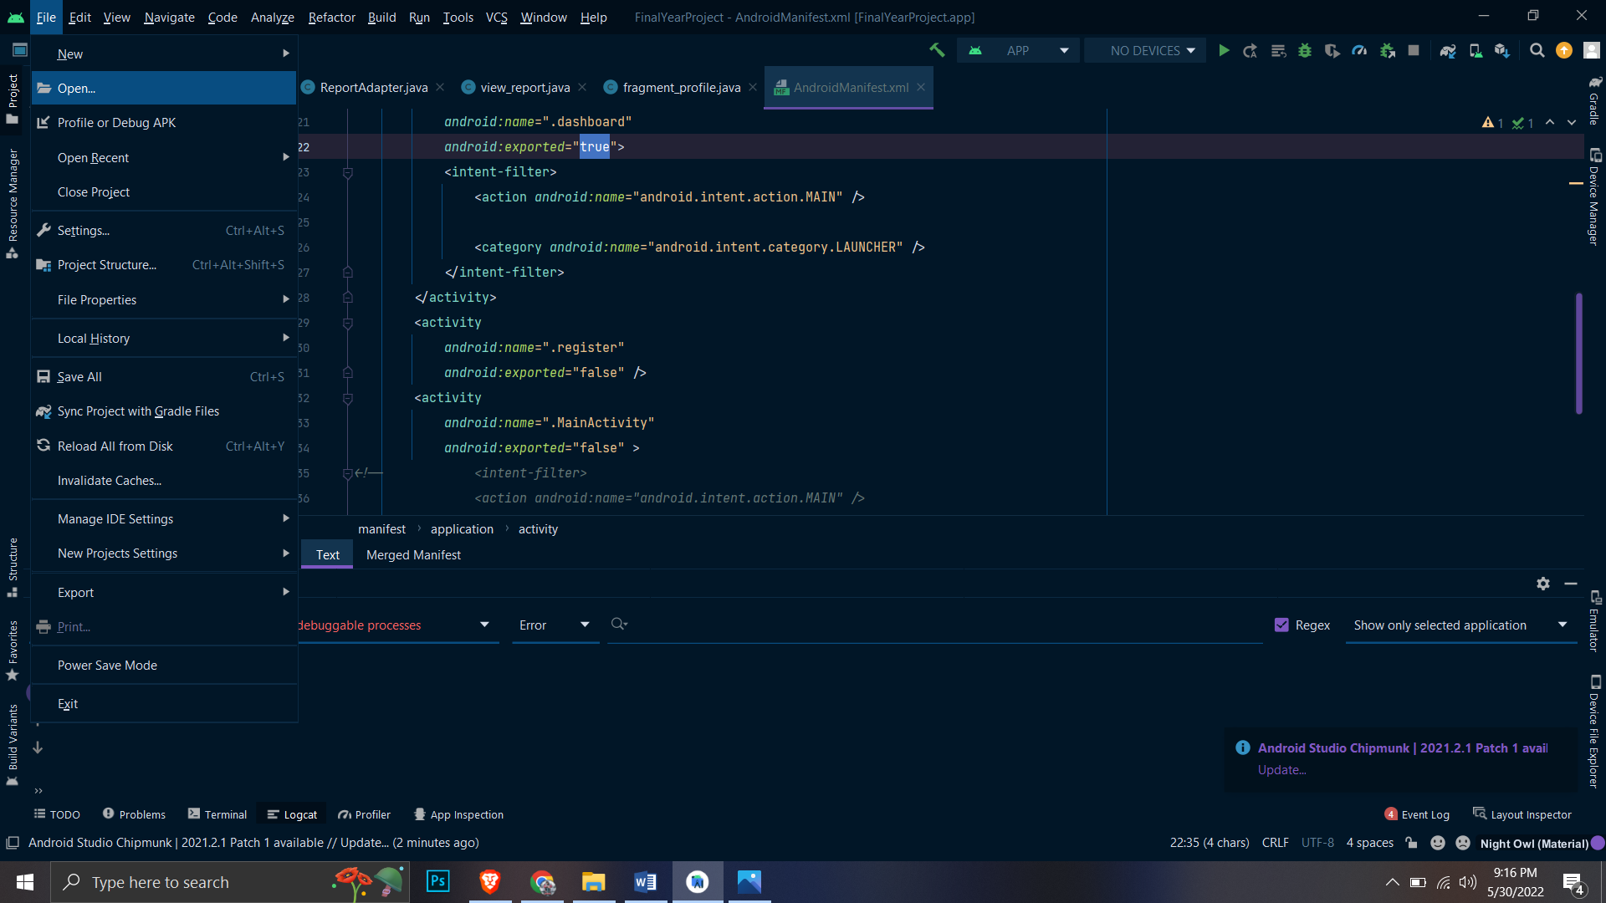

Fig 4: Opening Project

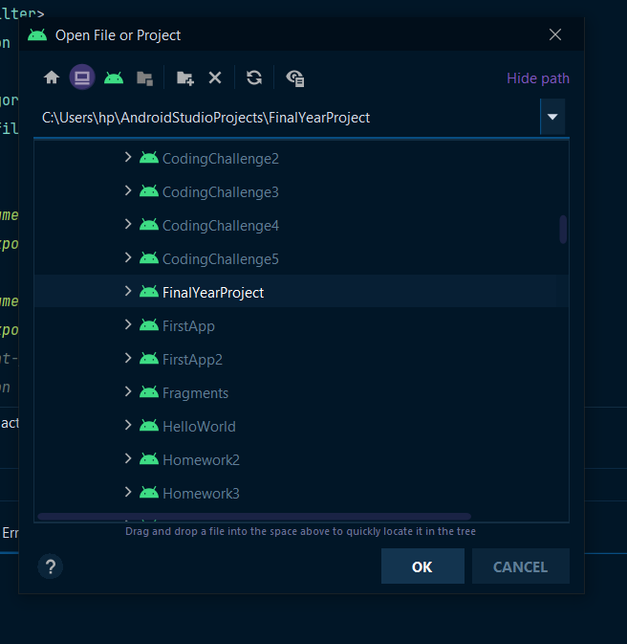

Fig 5: Searching FinalYearProject

1. After opening the project click on Android > Project > Android > Gradle Scripts > build.gradle

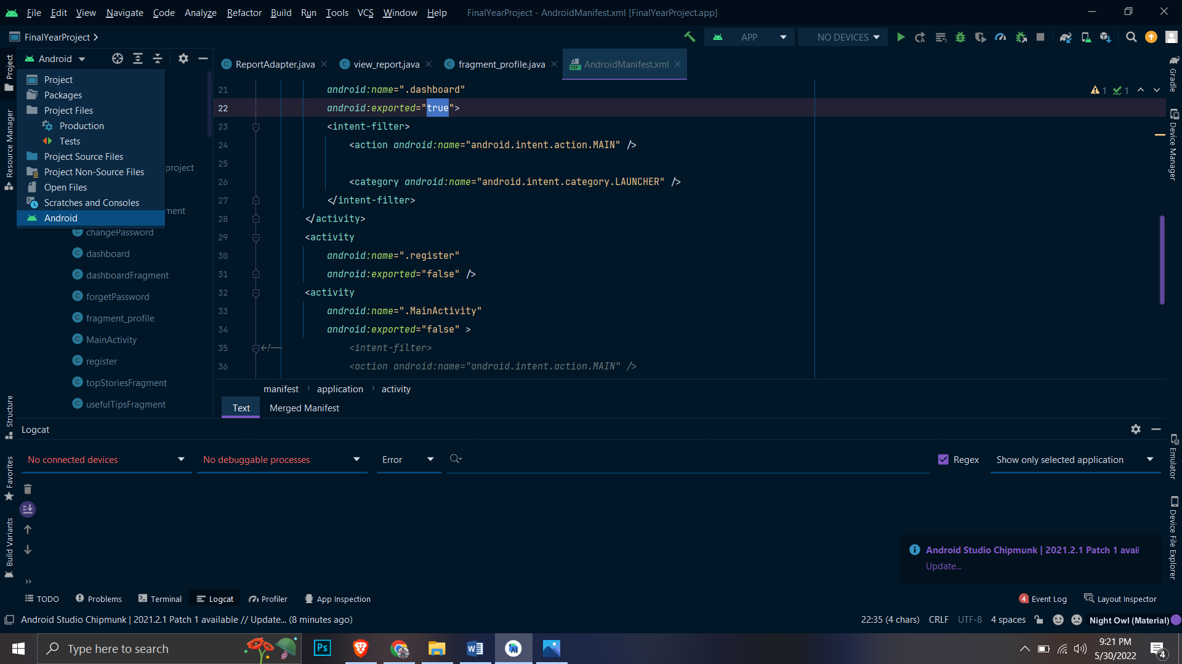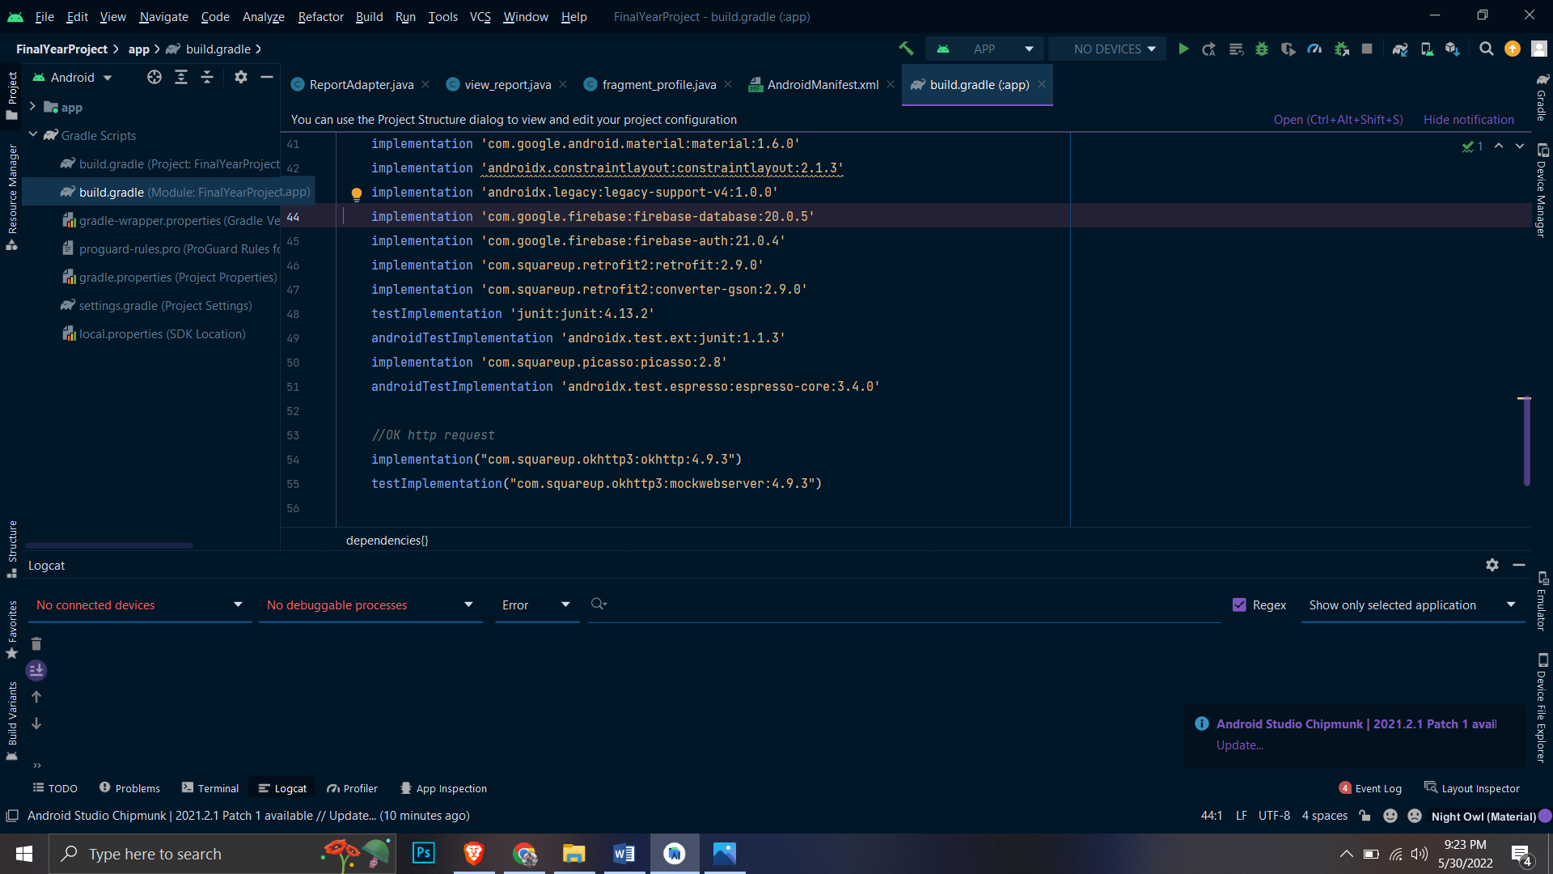

Fig 6: Opening build.gradle

1. Click on sync now as shown in Fig 7 and wait for project Gradle to be synced.

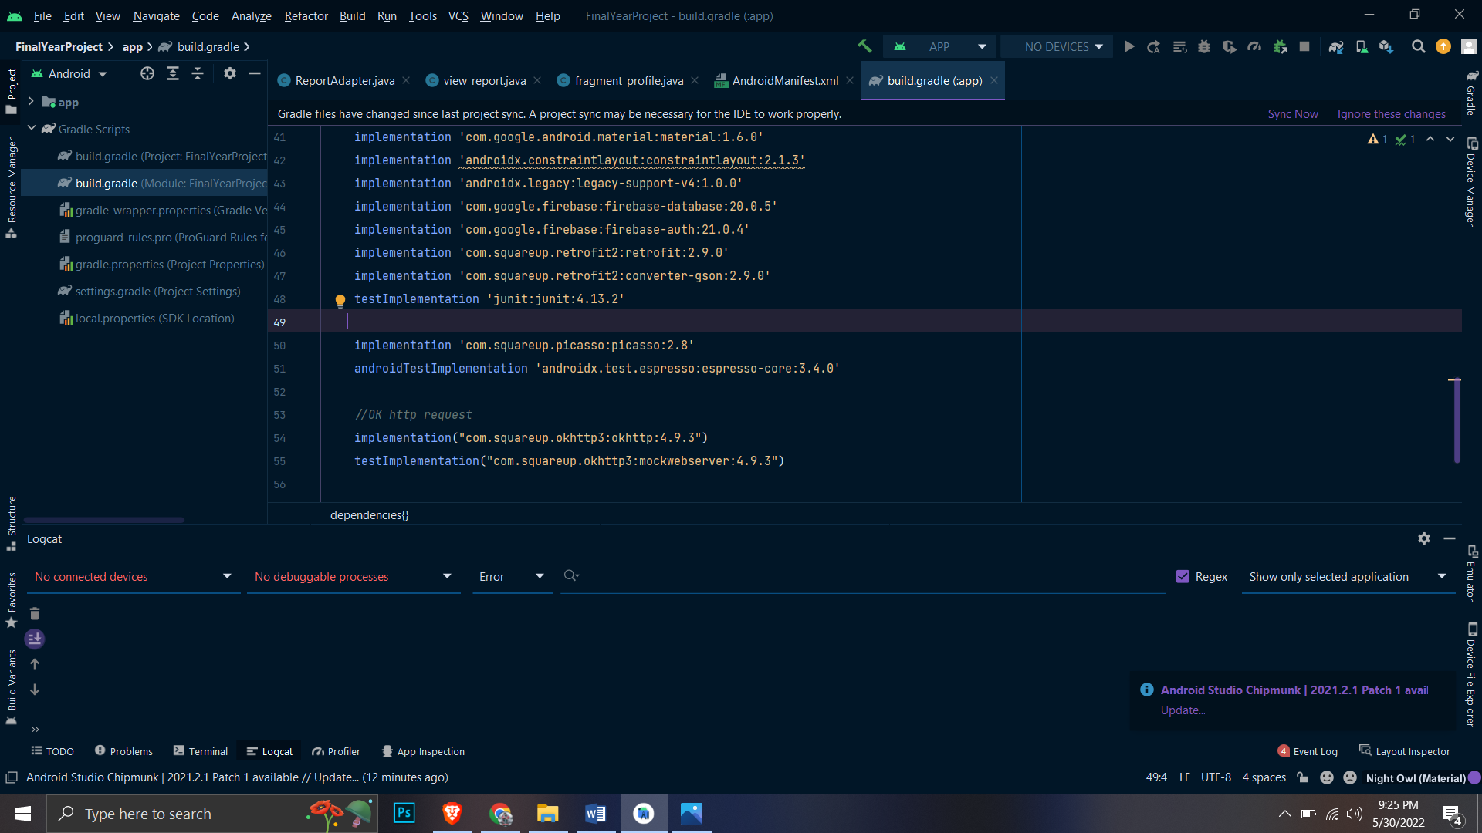

Fig 7: Sync Now

1. Then connect your external android device via Type C or Mini USB cable. Then it shows the device connectivity in top of the android studio as shown in Fig 8.

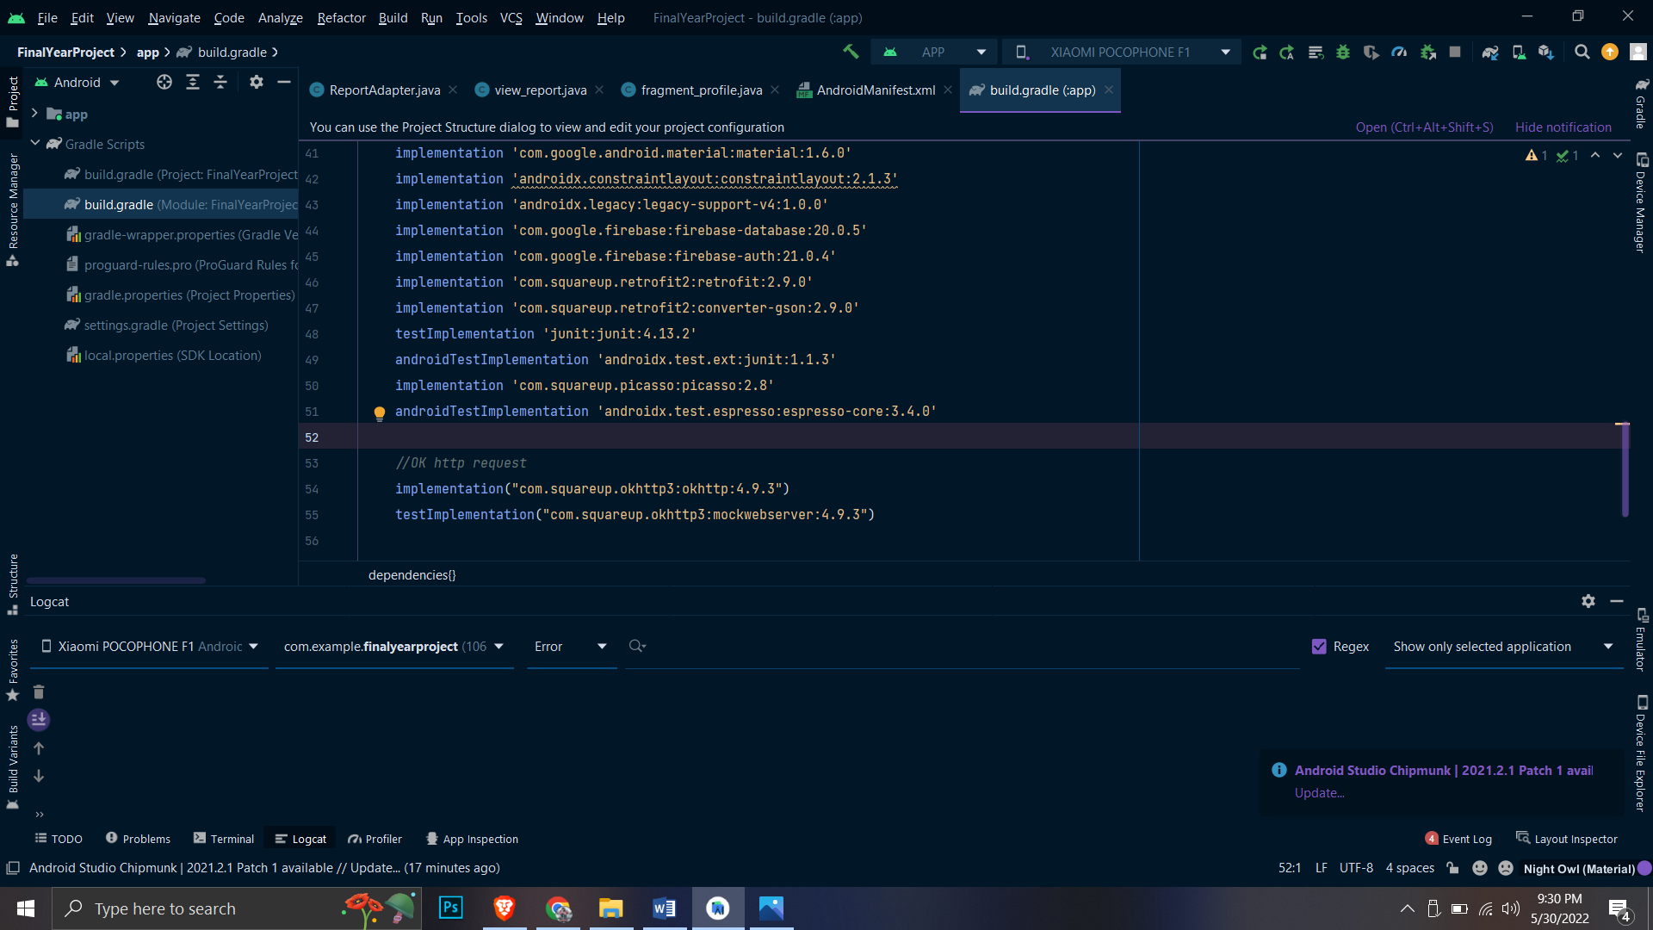

Fig 7: Device name displaying while connecting

1. Click Run button and run the application. As message must be shown in user’s device to get the permission to install the application. Accept the application permission and wait for an application to run.